**Posters: The Good and the Bad**

Sometimes, it helps to look at other posters to see what to do and what not do for your poster. Here, you will see examples of posters with good and bad elements. Use these suggestions to create a poster that is visually appealing and effective.



# Example 1

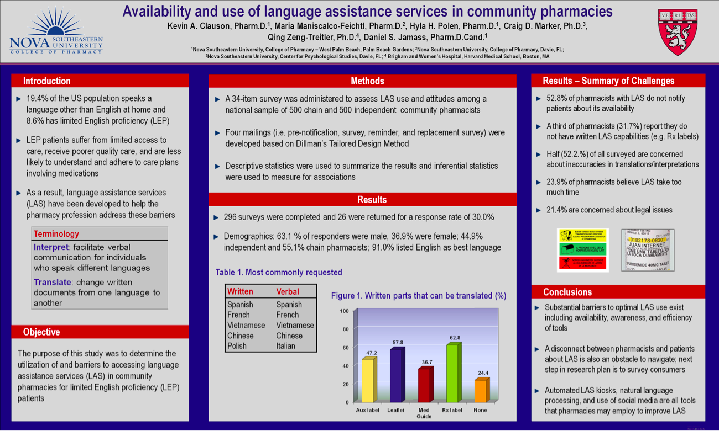

Source: Kevin Clauson; Copyright License

**The Good:**

1. Nice use of bullets
2. Not too text heavy
3. The figures are all useful and break up the text
4. The columns are aligned to guide the reader to read vertically
5. The title is written using a good format (not all caps)
6. Sans-serif fonts

**The Bad:**

1. The grey textbox backgrounds give the poster a dull look
2. The list of universities and icons in the title block look cluttered
3. There is no reference section
4. The overall color scheme is not the most pleasant
5. The middle column is not centered- notice the different spaces in the blue margins on either side of it
6. Textbox outlines or wider margins would better separate the text from the background
7. The 3D graph would be better as a 2D
8. Section titles are not justified consistently
9. Figure captions are above the figures, and not all figures even have captions

# Example 2

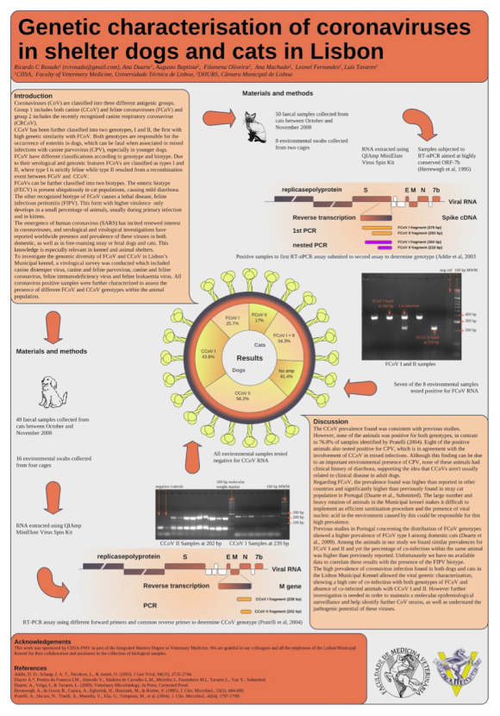

Source: Ricardo Rosado; Copyright License

**The Good:**

1. Acknowledgements and references in their own section at the bottom
2. Logos at the bottom

**The Bad:**

1. Overall disorganized look
2. It is difficult to know which way to read this poster, even with the arrows
3. The large blocks of text are intimidating to read
4. Title font is too large compared to the rest of the poster
5. The images blend together and are thus hard to interpret
6. No consistency between sections: some sections are in text boxes and other are not
7. The dark backgrounds for the title block and references draw your eye away from the body of the poster

# Example 3

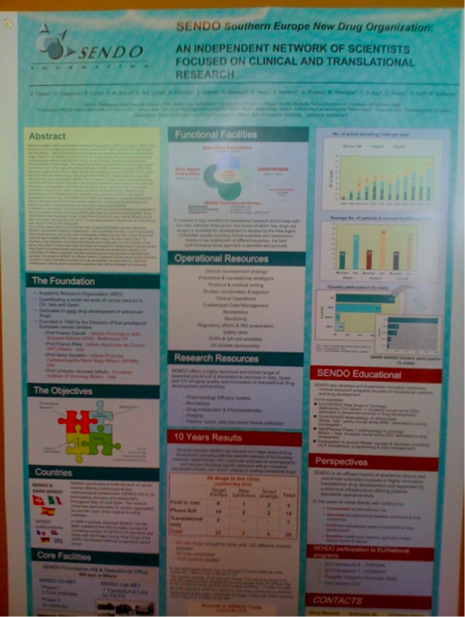

Source: Insightful Clinical Trials Search; Copyright License

**The Good:**

1. The sections are nicely aligned in columns
2. Pleasing color scheme
3. Section headings are highly visible
4. Use of figures instead of text

**The Bad:**

1. There is an abstract section
2. Too many sections
3. The logo is too prominent
4. The results are disjointed between two columns
5. Title is in all caps
6. The space between lines in the title is misleading
7. Unclear why the section headings are in different colors

# Example 4

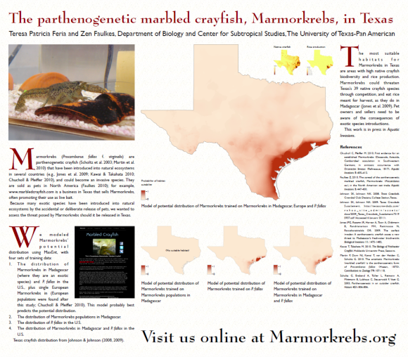

Source: ​Marmorkrebs.org

**The Good:**

1. Pleasant color scheme
2. Nice use of a background texture
3. Title takes up entire width of poster
4. The model image is a good display of the main purpose of the study

**The Bad:**

1. Title is serif font
2. Enlarged letter at the beginning of each section is unnecessary and distracting
3. Sections are not labeled
4. It is unclear where to start reading
5. The text boxes are justified resulting in too much space between characters.

Note “potential” in the second paragraph, and “habitat” in the third.

1. Link to the website is too large
2. Note that the square shape of this poster is not the traditional 3’x4’ dimension

# Example 5

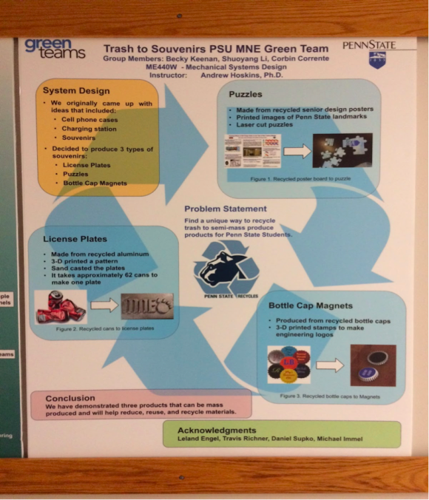

Poster displayed in Penn State’s Reber Building by Becky Kennan, Shuoyang Li, and Corbin Corrente

**The Good:**

1. Nice organization of text into different boxes
2. Good use of bullets
3. Not too many colors
4. Decent amount of white space

**The Bad:**

1. The order of what you should read on the poster is not logical
2. Flow of text would make more sense if overall if it was top to bottom, left to right
3. Awkward spacing for the class and instructor name at top
4. There is no reference section

# Example 6

Source: ​GA Tech College of Sciences

**The Good:**

1. Clear flow of text
2. Organized sections
3. Good amount of visuals

**The Bad:**

1. Too much text
2. A lot of columns
3. Long paragraphs with no bullets
4. Harsh yellow text

# Example 7

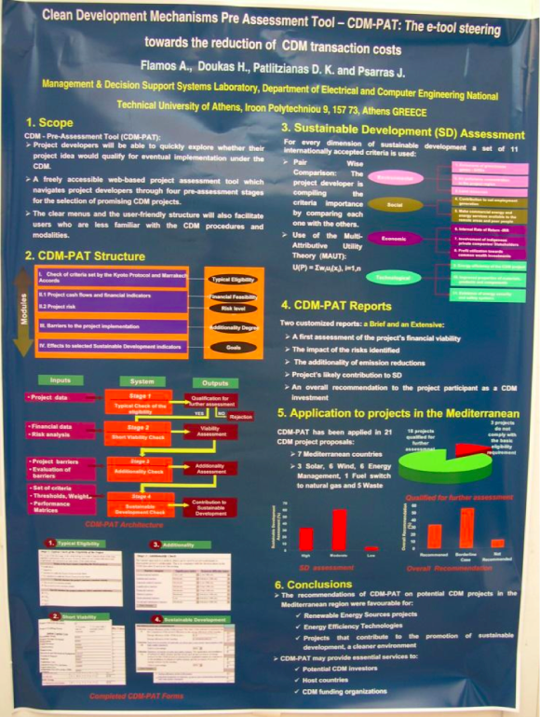

**Source:** ​**Diomidus Spinellis;** ​​**Copyright Licens**

**The Good:**

1. Several compelling visuals
2. Good use of bullets
3. Clear flow of text

**The Bad:**

1. Small text
2. Too many colours
3. Justified text boxes make for awkward text spacing in section 3
4. Missing a references section